Mickey Ganitch Memorial – Saturday, July 23, 2022. 9:00 am – Noon
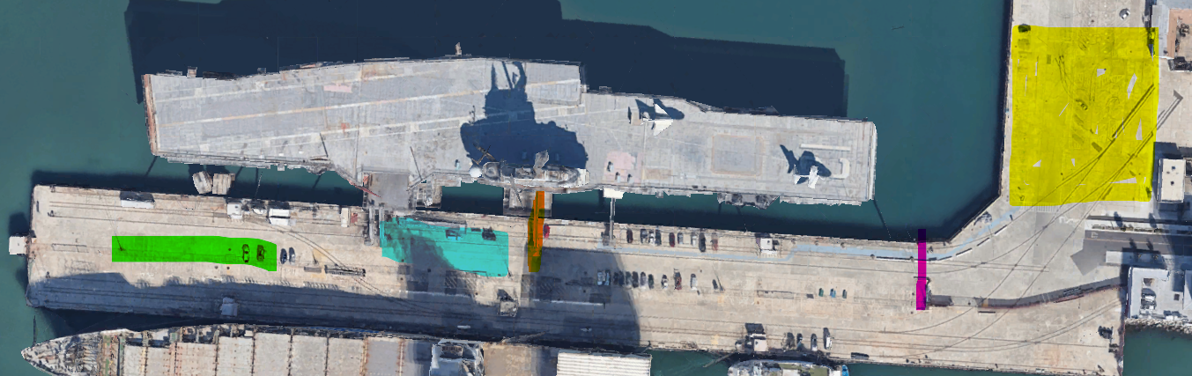
USS Hornet Sea, Air and Space Museum – 707 W. Hornet Ave, Alameda CA 94501

The Yellow is the visitors parking lot
The red is the entry to the crew parking lot – to drop off equipment proceed to the blue 3rd ramp and the lift will take your equipment to the Hanger Bay.
There is limited parking (15 spaces) at the end of the pier noted as green above. These are first come first serve for all exhibitors. If the pier is full, then you will need to exit the crew parking area and park in the yellow visitor parking area.
Please board the ship using the 2nd ramp “Security Ramp” noted in Orange

